Sustainability Series: Session 1
Creating a Legacy
Suicide Prevention Resource Center’s Workshop Series for 2nd Year GLS Grantees
Tuesday, June 24, 2014, 3-4:30 p.m. ET

Recording: http://edc.adobeconnect.com/p69uses7vgw/

Lobby Question: What does sustainability mean to you?

Rachelle Burns: The ability to not only continue our suicide prevention project, but take it to the next level.

Linda Howells: To continue our grant programs through collaboration among campus partners.

cortney gumbleton 2: The University administration believes our suicide prevention programming and educational efforts are essential to our University and our students.

Poll

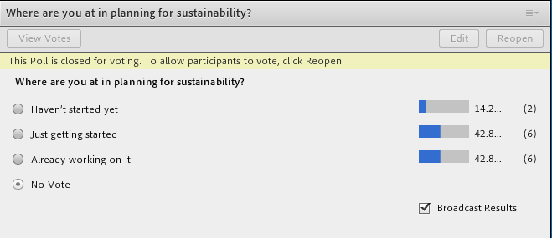

Questions Following Grantee Stories

Judith DeBonis: Would Misty please say a little more about the screenings that they did...there has been fear about screening on campus...will we have the resources to respond.

Laurie Sun Child: Misty ... what screening tool did you utilize while doing screening?

Communications for Sustainability Discussion

Rachelle Burns: We invited our VP for Student Affairs to be a key member of our Crisis Protocol Taskforce

Kathleen Pignatelli: Hi at Bergen Community College we had invited our Count Executive to programming and then to lunch to discuss Mental Health prior to the grant. Now we have freeholder and county support.

Julie Ebin: You can reach Misty directly for other questions at mvallen@health.nv.gov

Liz Brown 3: The program I work for is in an Urban area focusing on the Native American community. I have reached out to the Director of the Native American Program in our Public School area.

Dominique Lieu: Thinking back to the grantee stories, what were the goals and who was their audience?

Judith DeBonis: community agencies both clinical settings (field placements assoicated with various campus degress) and non-clinical (such as girl scout groups, senior centers etc)

Laurie Sun Child: Schools

Kacie Cohen: We developed an advisory board for our prevent suicide program, and the key members included residential life, student support services assistant to the dean, campus ministry, and the dean of students. Whom they found our program very valuable to their programs.

Jonathan Williams: I agree the overall goal is to get the word out on the status of the progress of the program as well as how much the proram impacts the campus.

Jennifer Martin: other state iniatives/programs whom we

Jennifer Martin: * whom we'd like to collaborate with

Kacie Cohen: A community foundation we also connected with were the "Life Foundation fighting AIDS Hawaii and the Pacific" were our LGBTQ club members from our school participated in their events.

Gregg Elliott: greggelliott@adams.edu if anyone wants to contact me directly for questions

Kacie Cohen: Mental Health America of Hawaii represenatives

Alison Brill: We've partnered with our state and regional suicide prevention coalitions, as well as other programs within our department and other state departments.

Jennifer Martin: With regards to what I noticed about their communication - I noticed one of the themes for each grantee included the need to "showcase" what you are doing so it's difficult to cut the program later; therefore more feasible to gain support.

Laurie Sun Child: As far as sustainability, does anyone have plans in place and are there idea's that can be shared with all?

Big Picture Worksheet Exercise

Objective 1: Increase the amount of training to Pensacola State College students, faculty and staff on suicide prevention and mental health promotion.
- key areas
  - Gatekeeper training:
  - Campus Connect
- (PTSD Seminars happened before the grant)
- objective successful?
- Trained 25 trainers
- Trained 90 individuals
- Could get additional data from the SPDC/Cross-Site data
- Want to better utilize the data that they have
- Anecdotal information: Get feedback from trainees that they are relieved to have something they can use
- challenges?
- 3-hr training was difficult to maintain. Modified this to a 2-hr training without cutting anything essential.
- Initial trainers were from diverse areas, but many didn't end up leading the trainings afterwards.
- Therefore changed their strategy to target particular groups -- e.g. Advising Department.
- Better when training requests came in rather than trying to have the trainers market them with no requests.
- Modified by also adding Kognito (upcoming)
- momentum?
- Have been getting lots of requests from key departments
- Focusing on offering the training to specific groups on campus
- Word of mouth from trainees
- Having Dept. Heads on board -- has presented at Dept. meetings
- long-term outcomes?
- Increase faculty and staff's abilities to identify vulnerable students and refer them to resources
- Increase understanding that suicide is a preventable problem

Objective 2: Increase help-seeking among Pensacola State College students and reduce stigma for seeking care for mental and behavioral health issues among students.
- key areas
  - Piggyback on Student Affairs Events/Outreach events
  - Increasing awareness of the national suicide prevention lifeline
  - create marketing material that relates to the students age, gender? (social marketing via twitter, instagram
- long-term outcomes?
  - Increased awareness of location, interest, and use of Counseling Center
  - Overall have more students get services
  - Students are more willing to tell friends / family/ others that they are struggling, without fear of being judged

Big Picture Worksheet Discussion

Dominique Lieu: What is the big-picture long-term outcome?

Judith DeBonis: increasing awareness of the national suicide prevention lifeline (getting that lifeline number included as a permanent item on student ID cards)

Kacie Cohen: create marketing material that relates to the students age, gender? (social marketing via twitter, instagram

Nicole Miller: Overall have more students get services

cortney gumbleton 2: Increased awareness of location, interest, and use of Counseling Center

Linda Wolszon: Students are more willing to tell friends / family/ others that they are struggling, without fear of being judged

Julie Ebin: Thanks all!

Dominique Lieu: Please download the Big Picture Worksheet below!

Julie Ebin: Once you've downloaded the worksheet, please start filling in the chart for one of your objectives

Solo Work Questions

Jonathan Williams: this actually feels as if much of the information this is looking for can come from our TRAC info. Is this correct?

