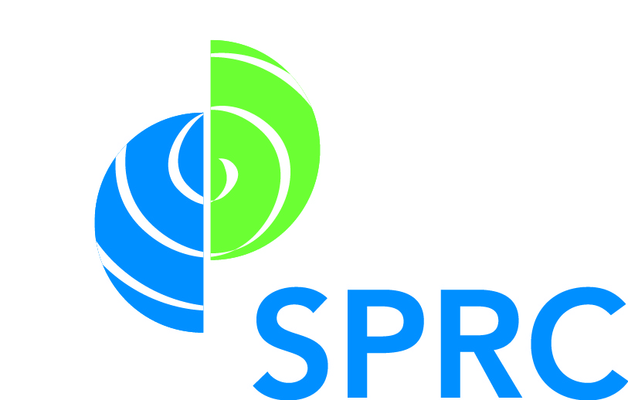
Cohort 9 Training Series
Partnerships Resource Sheet

SPRC Researching Prospective Partners Tool http://www.sprc.org/sites/sprc.org/files/C3%20Researching%20Prospective%20Partners%20FINAL%20Sept2013_0.pdf
This resource helps programs establish key perspectives and priorities of partners they want to engage in their efforts.

SPRC Memorandum of Understanding Checklist (http://www.sprc.org/sites/sprc.org/files/C1%20Creating%20a%20Partnership%20Memorandum%20of%20Understanding_FINAL%20Sept2013_0.pdf)
This resource provides key criteria to ensure your partnership agreement has included all the details and information it needs to withstand challenges that may arise.

UIHI Resource Guide: Formalizing Partnerships through MOAs (http://www.uihi.org/projects/health-equity/partnership/)
This resource guide introduces the basics and benefits of Memorandums of Agreement and provides steps for developing MOAs with partners

SPRC Substance Abuse and Suicide Prevention Collaboration Continuum (http://www.sprc.org/states/collaborationcontinuum)
These webpages contain a collection of practical tools and resources to help partners be more effective and strategic in their work together.

SPRC Customized Pages: Health Care & Behavioral Health Providers
(http://www.sprc.org/for-providers)
The Health Care and Behavioral Health Providers web pages contain resources, information, and tools to assist you in making suicide prevention an integral part of your practice.

CDC Connecting the dots: An overview of the links among multiple forms of violence
(http://www.cdc.gov/violenceprevention/pub/connecting_dots.html)
The brief shares research on connections between different forms of violence to support the coordination and integration of responses to violence in a way that considers the individual in the context of their home environment, neighborhood, and larger community.

CDC Partnership Evaluation Guidebook and Resource (http://www.cdc.gov/obesity/downloads/partnershipevaluation.pdf)
This guide applies the CDC Evaluation Framework to evaluating your partnerships, laying out a six-step process for the decisions and activities involved in conducting an evaluation.

WHO Partnership Building Toolkit (http://www.who.int/workforcealliance/knowledge/toolkit/35/en/)
This toolkit aims to offer easily accessible tools to support the partnership process, offering guidance on identifying potential alliance partners; facilitating a dynamic and helpful kick-off meeting; creating an appropriate memorandum of understanding; and more.

Coalitions Work Coalition Effectiveness Inventory (CEI)
(http://coalitionswork.com/wp-content/uploads/coalition_effectiveness_inventory.pdf)
Offers a diagnostic checklist for coalition staff and key leaders to assess coalition effectiveness.

Wilder Collaboration Factors Inventory
(https://www.wilder.org/Wilder-Research/Research-Services/Pages/Wilder-Collaboration-Factors-Inventory.aspx)
A tool to assess how your collaboration is doing on 20 research-tested success factors.

CoalitionsWork
(http://coalitionswork.com/resources/tools/)
The website provides tools to help program assess a community’s readiness to collaborate; build a coalition; assess and enhance existing partnerships; attract resources and members; and implement effective programs and evaluate outcomes.

